Positive Behaviour Framework – Revised April 2017

Introduction
We constantly review how our strategy to support behaviour is working and have consulted with all stakeholders over the past few months in order to reach agreement around what works and what causes issues in terms of promoting positive behaviour.
The purpose of this statement is to guide teachers, parents and pupils as to an agreed standard of behaviour in school which will allow all pupils to enjoy a positive environment which will promote successful learning and teaching.

Aims and Expectations

Children work well when there is a recognised structure where they know that there are limits to what is acceptable. We would like our children to come to school ‘ready to learn’. The majority of children do, but for those who disrupt lessons or play, we have developed a framework to allow us to have structure and be consistent.

Our core expectations encapsulate what we expect in order for children to be ready to learn
- Be safe
- Be fair
- Work Hard

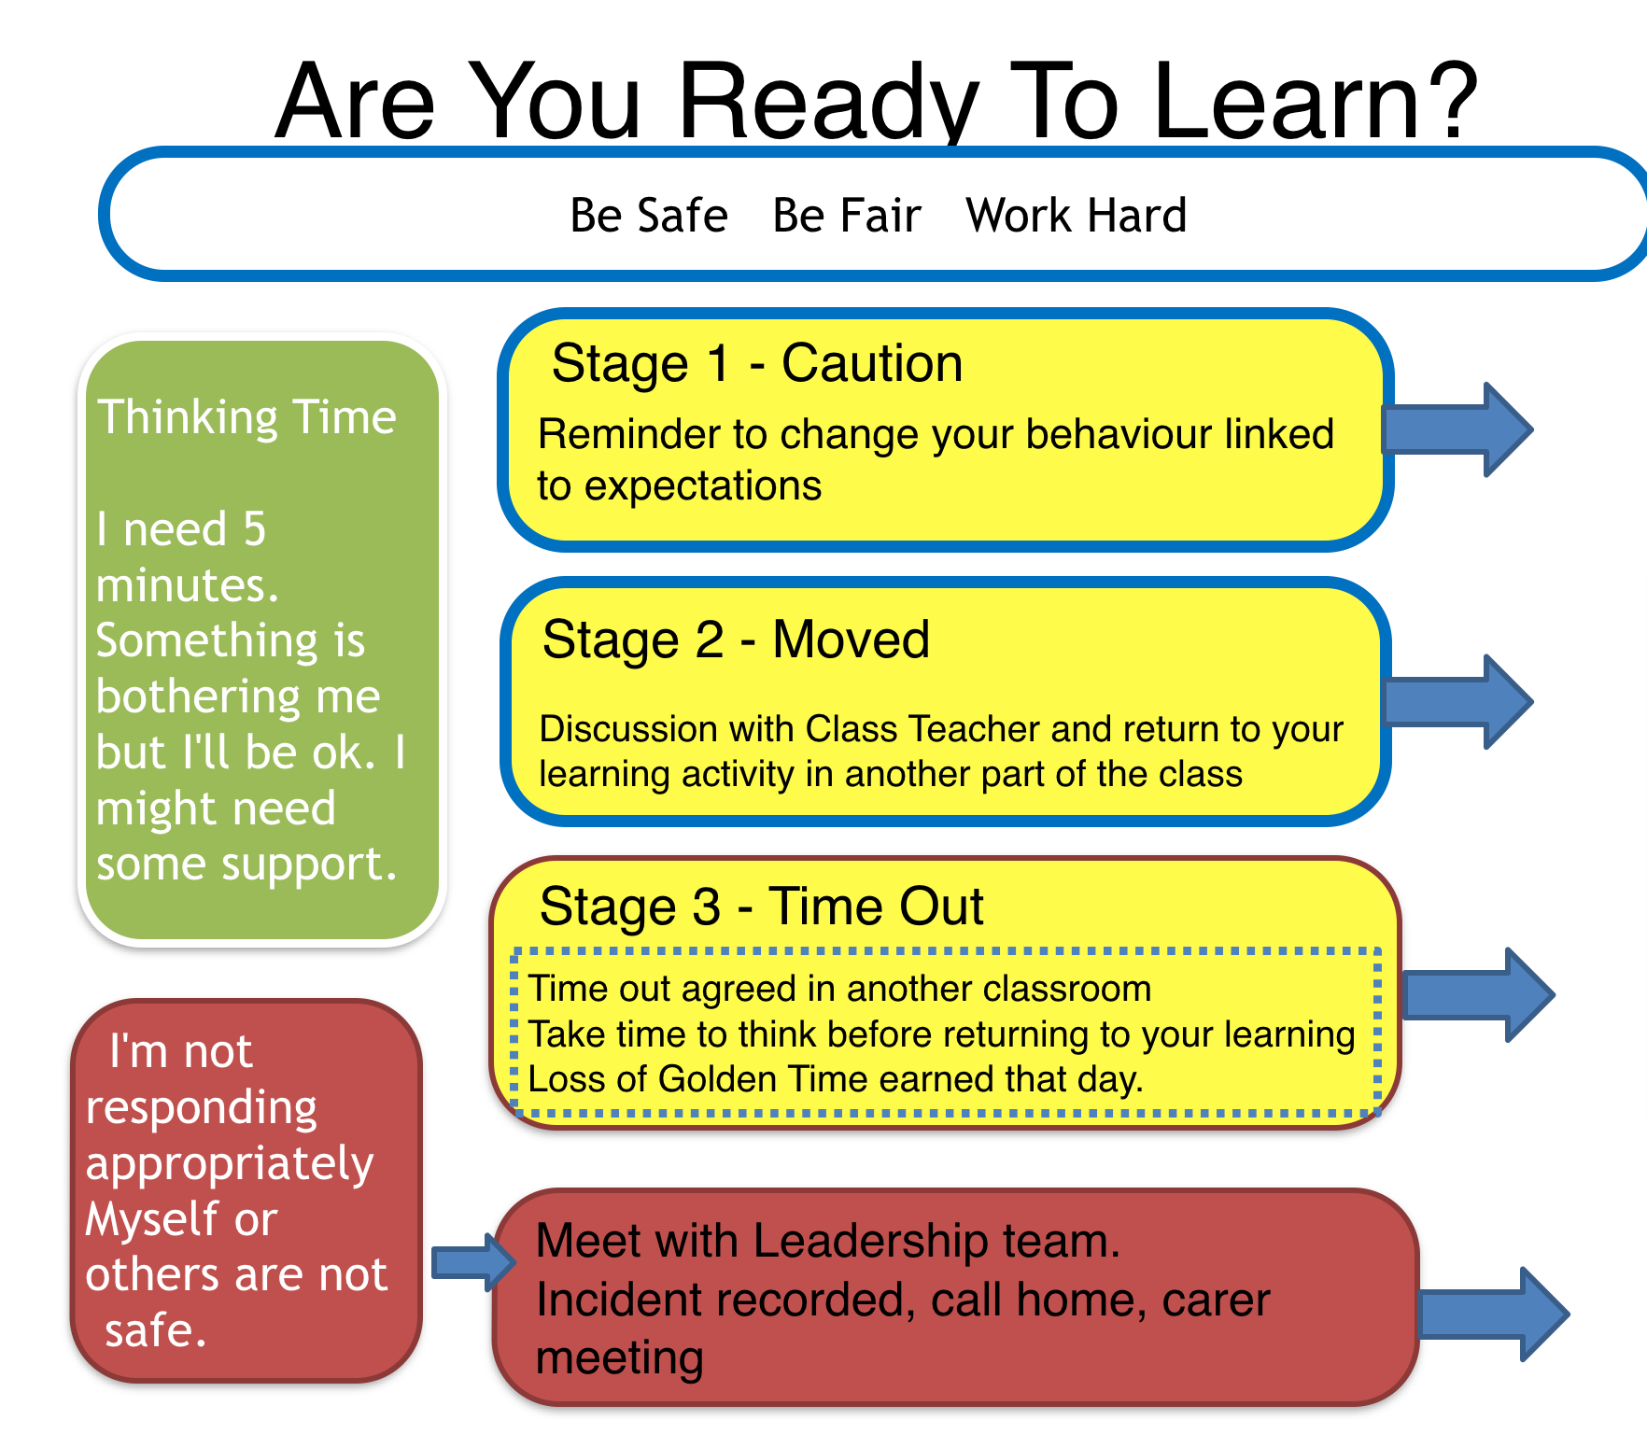

  - Some behaviours will result in pupils being sent to the Senior Management Team straight away
  - Children requiring ‘time out’ from a classroom/activity should be sent out with either a non-teaching member of staff (learning assistant) in the first instance, or the agreed class teacher where appropriate for an agreed period of time with appropriate tasks to complete

Children may behave inappropriately when they are facing difficulties both in school and outwith the school environment. We will always seek to discover and support the reasons for any inappropriate behaviour.

Close communication between home and school is therefore vital and every effort will be made to communicate clearly to maximise the value of the partnership.

Celebrating Success
Golden Time

Golden time is linked to our expectations. Children are able to embark on an activity of their choice in each block on a weekly basis. Children start each week with 5 minutes of Golden Time and each day can earn 5 minutes for not receiving a third warning. This can accumulate to 30 minutes on a Friday.

In addition, all staff will accompany children in the playground every Monday from 10:30 to 10:45 for Golden Break. This is used to help develop and maintain relationships with children and interact with them in a different context.
House System
The school operates a house system which encourages a sense of identity and collaboration across the school. Points are awarded by all staff for demonstrating respect and excellence across the school. In addition, our children earn points for lining up in each block to develop collaboration through the classes.
Each term the House will the most points will be allocated the House Trophy for the term and be given an additional 50 points towards Sports Day.

Tea with the HT/DHT
This is used to promote excellence in learning in the classes and children are given the opportunity to share their successes with the SLT. Class Teachers choose this on a weekly basis focusing on achievements in learning using the Legendary Learning List and Midlothian Learner to support. Children will receive their certificates as part of the assembly programme on Monday.

Other certificates that have previously been issued during assembly will now be issued in class. Maths Magicians and Star Writer will be given out on a weekly basis by all class teachers.

Pupils With Additional Needs

We recognise that pupils’ difficult behaviour can be a symptom of complex underlying difficulties. We aim to promote and maintain high standards of behaviour throughout our school. We recognise that, for certain pupils, other measures may be undertaken. It is important to tailor our management of these pupils to the needs of the individual. It is also important that other pupils see that staff are fair and a discussion may be required to establish why certain behaviours may – in their eyes- be dealt with differently. This is a sensitive issue and requires sensitive handling. Reassurance is necessary for pupils as some behaviour can be unnerving or alarming. In an inclusive school it is important that we all appreciate the difference in all of us.

Summary

We hope that this statement is helpful and informative. It is important to share any concerns you have with us. By working together in partnership we will be able to support any concerns regarding behaviour and make school life a safe and enjoyable experience for all.

April 2017

