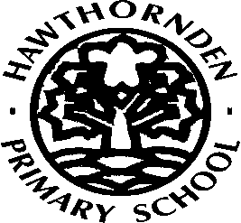

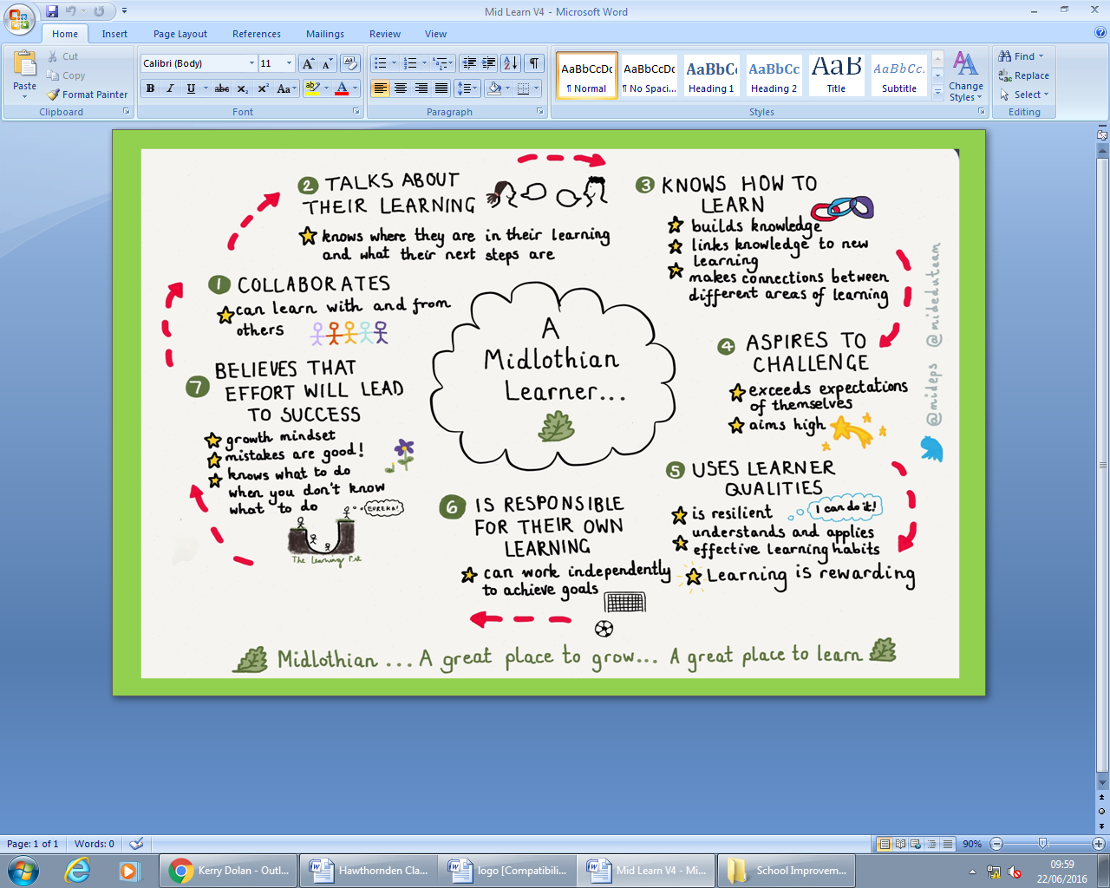

* Tracking Tool

*Achievements

*Baseline Evidence

*Questionnaire Feedback

*Self Evaluation

*Parents Feedback

*Assessment Capable Learners

*Aspiration

* Ethos

*Moderation

*What a level looks like

*Tracking

*Assessment Dialogue

*Skills Session

* PAT PALS

*Home Learning

*Vision, Values, Aims

*Targets

*Twitter

*Blog

*Reading Groups

*Moderation

*Professional Dialogue

*CLPL

*Working Parties

*Focus Groups

*Co-ordinators

*Literacy and Numeracy

co-ordinators

*Pupils Council

*Learning Council

* Pupil/Parent Voice

*HWB

*What a level looks like

*Closing the Gap

*Skills Development

*Vision, Values, Aims

*Visible Learning

**School Improvement Planning – 2016 /2017**