

**Learning today, tomorrow, forever**

**Visible Learning is based on a professional development programme that explores how evidence can be used to create innovation in the learning environment. John Hattie’s 15 years of educational and scientific research on ways which can improve learning and teaching. Professor John Hattie was interested in the factors that have a positive impact upon teaching and learning as well as the factors that raise attainment.** It is about making pupils learning visible to teachers so they can know whether they are having an impact on this learning (Know Thy Impact). Further, it also refers to making teaching visible to the pupil as well so that pupils learn to become their own teachers, an important component of becoming lifelong learners – something we want all pupils to value.

* **Learners are at the centre of a Visible Learning approach.**
* **Learners become teachers and teachers become learners**
* **Learning is Visible – learners know what they learning and how they learn**
* **Shared and common Language of Learning**
* **Learners can talk about their learning and create next steps – Assessment Capable Learners**
* **Feedback needs to be effective have ‘stickability’ therefore it needs to be personal to the child and ‘just in time’**
* **Inspired and Passionate teachers help to develop Assessment Capable Learners.**

**3 key questions to help us on our journey are;**

“Where am I going? How am I doing? Where to next?”

We have gathered lots of evidence to help us look at where we are and where we are heading to next – What makes a good learner? Can pupils talk about their learning? Do pupils understand the Language of Learning?

We will make our findings Visible at Parents Consultations so you can see where we are.

If you are passing through our school have a look on our School Improvement Wall for information and evidence.

**During Term 1 we have been working through our ‘Establishment Phase’. This phase has had key focuses for all teaching staff and classes. These focuses have helped to lay the** solid foundations for good quality learning environments. We have chosen concepts that support visible learning to ensure that our staff and pupils have an understanding of these as we continue forward on our journey. Our aim is to embed these concepts and principles, whilst carefully ensuring we are looking at the impact they are having – Know Thy Impact.

Our key focuses have been;

**Pupils have learned about how the brain works. They have investigated the different parts of the brain and how our brain is like a muscle and it can grow by making new connections and challenging yourself.**



*“The brain has different parts that control different things like you balance, imagination and memory. It is an important organ in your body and is protected by your skull. You have neurons in your brain that make connections. You can make up to 175 connections in a second!”*

*Kalli and Anna P5b*

*“Your brain grows when you learn new things and when you challenge yourself. “*

*Isaac P6a*

We have developed a Growth Mindset culture where we focus on changing our words to change our mindset; “ I can’t do this” becomes “I can’t do this yet.”

In a fixed mindset pupils believe their basic abilities, their intelligence, their talents, are just fixed traits. They have a certain amount and that's that.

In a growth mindset pupils understand that their talents and abilities can be developed through effort and persistence.

At Hawthornden we are encouraging all learners to have a Growth Mindset.

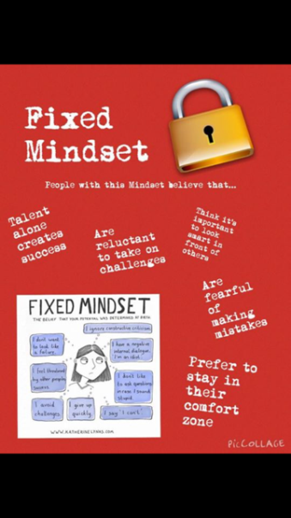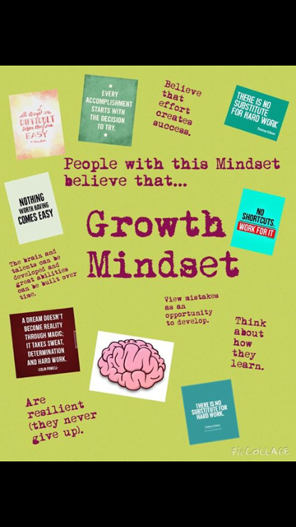

*“A Growth Mindset is where you keep trying and don’t give up. I didn’t give up when I got my new scooter. My Dad helped me and I kept trying and it easier and easier. I didn’t give up.”*

*Mirren R P2a*

*“ A Fixed Mindset is where you think you can’t do something and you say – I can’t do it. You stop trying!*

*Finlay P2b*

We are in the process of creating a culture where mistakes are seen as learning stepping stones and learning opportunities. Pupils are not to see mistakes as negative or bad but as opportunities to develop and extend their learning. Mistakes can be beautiful, mistakes help us learn. Teachers make mistakes too... ☺

*“Mistakes help you learn” – Summer P3b*

*“Mistakes are good for you because you can learn from them” – Ella P3b*

*“Mistakes are your best teacher in life because you learn from them” Kyle P7b*

*“ I don’t mind making mistakes, they help me learn and I can do better work.” – Kadan P1a*

In order for pupils to be able to talk about their learning we have been working on discussing and explaining in detail the words we use to describe our learning. It is important our pupils have an understanding of the words we use when we learn. We aim to build a learning dictionary that has lots of words and their meanings so that pupils can refer to them.

Some of the words we have been investigating are;

*“It is all about the skills we use when we are learning. It is about the words we use to help us understand what we are learning. They appear in our Learning Intentions and Success Criteria. – Codie P6a*

*“It helps describe what you are learning and how you are learning” – Arran P7*

Our next step is to look at how we learn and the process we go through when we learn. We are encouraging learners to think about when they learned something new and the process that they went through. Hopefully our pupils will be able to draw upon their knowledge of mistake making and Growth Mindset to support their thinking.

This is the next step in our data gathering process. This data will help us refine and decide upon learning powers/dispositions that learners in Hawthornden use to help them to become better learners.



We need your help so that you can share the same key messages at home, that we are sharing and promoting in school. You can help support your child at home by;

* Asking ‘what did you learn today?’
* Show interest and appreciation on the process and effort of learning
* Celebrate mistakes – ensure that pupils understand the mistakes they have made and how mistakes help them learn?
* What mistakes did you make today?
* The power of ‘yet’ “I can’t yet”
* Encourage challenge – “What challenged you the most today at school?
* What are your next steps in numeracy? What will help you achieve your target?

Follow our school Blog – [misskdolan@wordpress.com](mailto:misskdolan@wordpress.com)

Follow us on Twitter - @HawthorndenPrim

Follow our class blogs via our website – www.hawthornden.mgfl.net

